Project Title
Quick-Commerce Location Intelligence & Expansion Strategy
A Geospatial Decision-Support System for Dark-Store Expansion in India
Tools: Python • Pandas • GeoPandas • Geospatial Analysis • OpenStreetMap • Interactive Mapping • Location Scoring

1. Project Overview
India's quick-commerce industry is highly dependent on location.
Unlike traditional retail, dark stores must be positioned close enough to demand centers to support rapid delivery while avoiding excessive competition and market saturation.
This project develops an end-to-end location intelligence system for evaluating quick-commerce expansion opportunities across India.
The analysis integrates 4,081 dark-store locations belonging to:
- Blinkit — 1,954 stores
- Zepto — 1,089 stores
- Swiggy Instamart — 1,038 stores
Blinkit represents 47.9% of the observed network, while Zepto and Instamart account for 26.7% and 25.4%, respectively.
Rather than simply asking where stores currently exist, the project addresses a more important business question:
Where should a quick-commerce company expand next?

2. Business Problem
Quick-commerce companies need to continuously expand their delivery networks, but selecting a new dark-store location is complex.
A location with a large population may not necessarily have strong commercial demand.
Similarly, a high-demand market may already contain several competing dark stores.
The expansion decision therefore requires balancing:
Demand + Competition + Brand Position + Store Density + Local Environment
Central Business Question
Which Indian markets and micro-locations provide the strongest opportunity for quick-commerce expansion after accounting for demand, competition, brand strength, geographic density, and local market conditions?

3. Business Objectives
The project aims to:
- Understand the existing quick-commerce network across India.
- Compare the geographic footprints of Blinkit, Zepto and Swiggy Instamart.
- Validate store coordinates before spatial analysis.
- Identify geographic clustering and overlapping competitive zones.
- Measure retail demand across markets.
- Examine the micro-environment surrounding individual dark stores.
- Quantify competitor pressure and local brand strength.
- Identify markets where demand exceeds competitive saturation.
- Build a 0–100 Location Opportunity Score.
- Test whether recommendations remain stable under different business priorities.
- Convert analytical scores into expansion strategies.
- Build an interactive location intelligence engine for evaluating new locations.

4. Dataset & Analytical Layers
The project combines multiple information layers.
Dark-Store Network
4,081 store locations
Brand | Stores | Network Share
Blinkit | 1,954 | 47.9%
Zepto | 1,089 | 26.7%
Swiggy Instamart | 1,038 | 25.4%
The analysis finds that these networks are cluster-driven rather than uniformly distributed, and their geographic footprints overlap across several markets.
Additional Intelligence Layers
Demand Intelligence
- Population
- Workforce strength
- Retail Demand Index
- Market-level attractiveness
Spatial Intelligence
- Latitude
- Longitude
- Geographic distance
- Store density
- Market proximity
Micro-Location Intelligence
- Residential areas
- Commercial activity
- Public transport
- Education hubs
- Healthcare
- Shopping hubs
Competitive Intelligence
- Local brand share
- Competitor pressure
- Store density
- Competitive whitespace

5. Technology Stack
Technology | Purpose
Python | Main analytical environment
Pandas | Data manipulation
NumPy | Numerical calculations
GeoPandas | Spatial analysis
Matplotlib | Analytical visualizations
OpenStreetMap | Micro-location/environment features
Geopy / Geographic Distance | Market matching
Folium | Interactive maps
ipywidgets | Interactive location-analysis interface
Jupyter Notebook | Complete analytical workflow

6. Project Architecture
Complete Analytical Pipeline
Raw Dark-Store Data
↓
Data Integration
↓
Spatial Validation
↓
Geographic Network Analysis
↓
Retail Demand Intelligence
↓
Micro-Location Intelligence
↓
Competitive Intelligence
↓
Opportunity Engineering
↓
Location Opportunity Score
↓
Sensitivity Analysis
↓
Market Segmentation
↓
Interactive Location Intelligence Engine
This progression is important because each notebook adds another layer of decision intelligence instead of functioning as an isolated analysis.

7. Notebook 1 — Quick-Commerce Market Landscape
Objective
Create a unified view of India's observed quick-commerce dark-store network.
The Blinkit, Zepto and Swiggy Instamart datasets are standardized and combined into one master dataset containing 4,081 locations.
Key Findings
Blinkit leads the observed market with 47.9% of stores.
Zepto and Swiggy Instamart operate at similar network scales.
However, the analysis reveals an important distinction:
National scale ≠ local dominance.
All three networks form geographic clusters and overlap in multiple areas.
Business Insight
Competitive pressure should therefore be measured locally, rather than using national store counts alone.
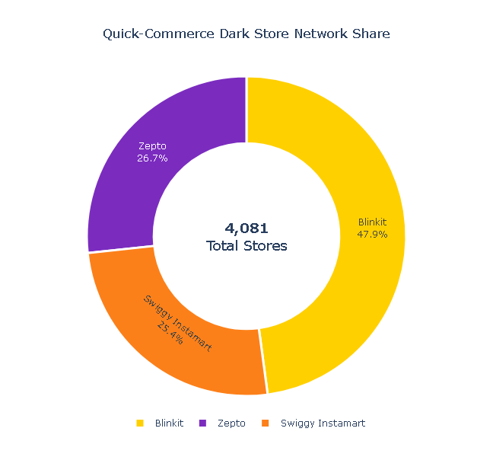
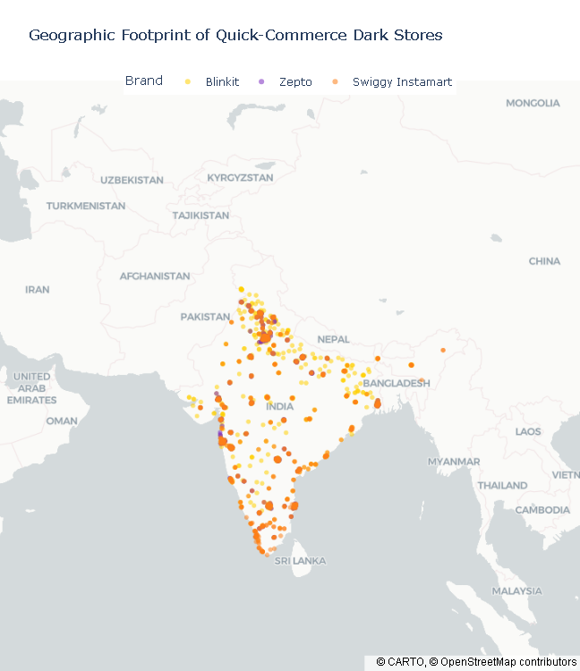
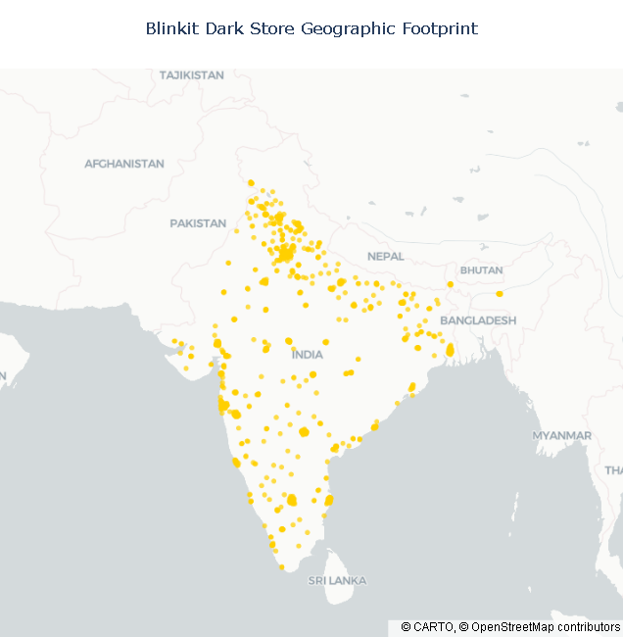
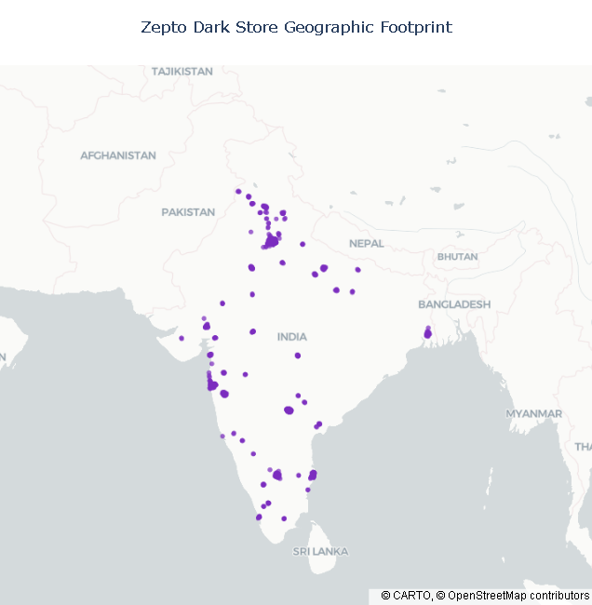
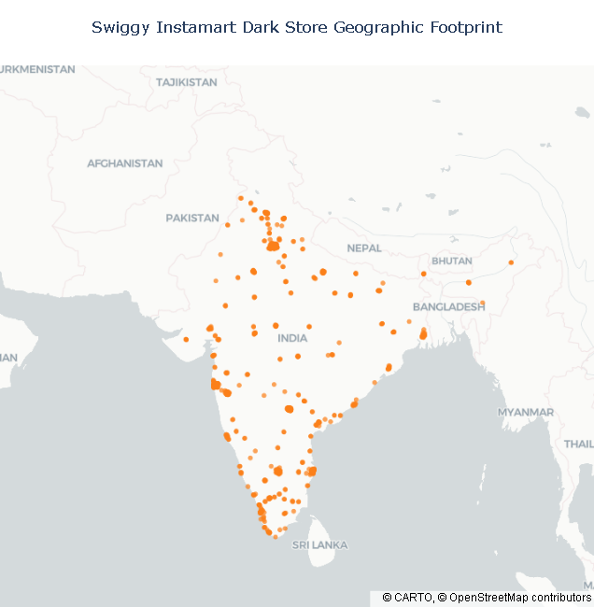
8. Notebook 2 — From Raw Points to Trusted Locations
Before building any geospatial model, the project validates whether the store coordinates are reliable enough for analysis.
Results
4,081 / 4,081 locations contain coordinates
100% coordinate coverage
100% pass the defined geographic validity check
Only 1,954 stores (48%) contain accuracy metadata.
However, missing accuracy metadata does not mean the coordinates themselves are invalid.
Important Decision
Instead of discarding approximately 52% of the dataset, all geographically valid records were retained.
Core Finding
Complete spatial coverage can be retained despite partial accuracy metadata.
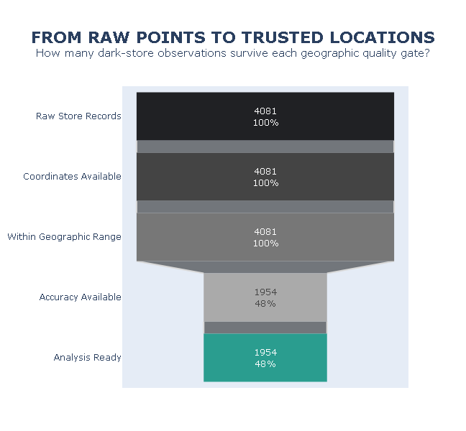

9. Notebook 3 — Geographic Network Structure
This stage investigates how the three networks are distributed across India.
Questions
- Which brand has the largest network?
- How far does each network spread east–west?
- How far does each network extend north–south?
- Where do competitor networks converge?
Key Findings
Blinkit has the densest footprint due to its larger network.
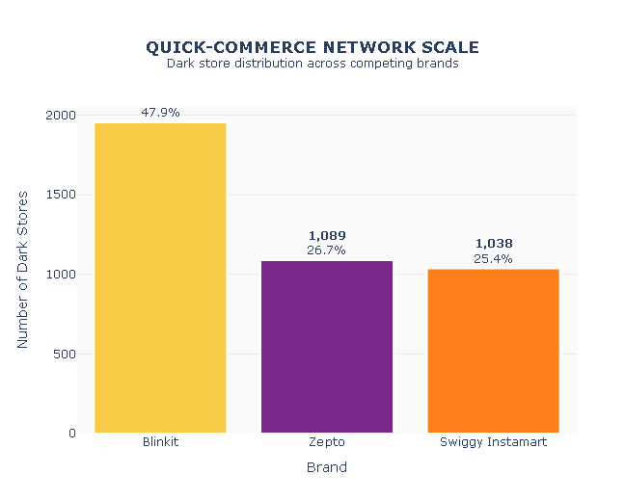
However, latitude and longitude distributions show similar concentration bands across brands.
This suggests that competitors repeatedly target similar geographic regions.
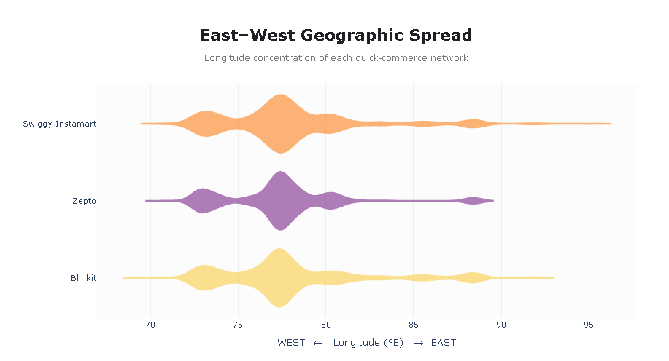
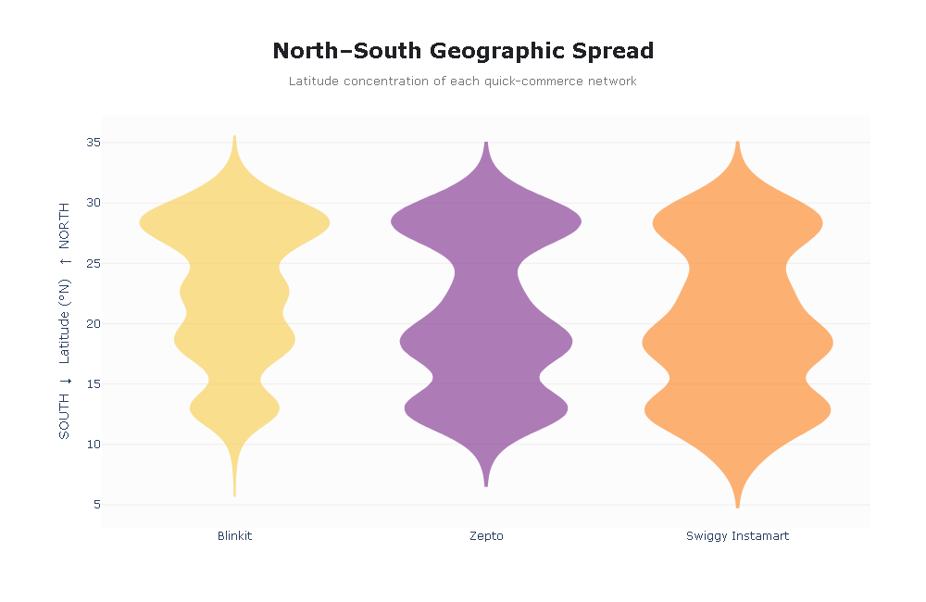
Core Finding
Network leadership is national, but competitive pressure is local.

10. Notebook 4 — Retail Demand Intelligence
A city should not be attractive simply because it has a large population.
The project therefore introduces a Retail Demand Index (RDI).
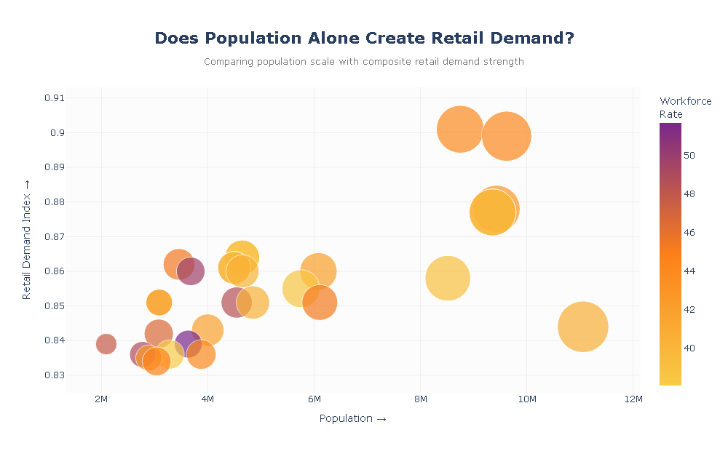
Population vs Demand
The analysis finds that:
Population → Market Scale
but
RDI → Market Quality
Markets with similar populations can have significantly different demand profiles.
Strongest Demand Markets
Market | RDI
Bangalore | 0.901
Pune | 0.878
Mumbai Suburban | 0.877
Bangalore emerges as the strongest retail-demand market in the analysis.
Key Insight
High population does not automatically equal high-quality demand.
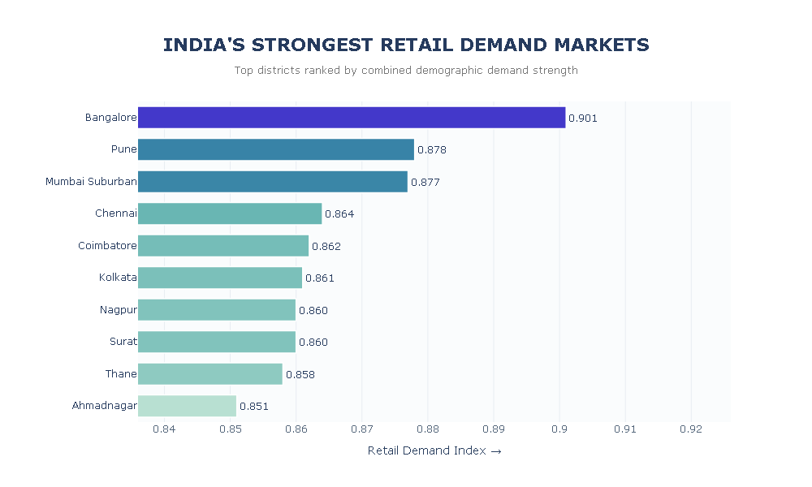

11. Notebook 5 — Micro-Location Environment Intelligence
City-level demand is not enough.
Quick-commerce operations depend on the environment surrounding an individual dark store.
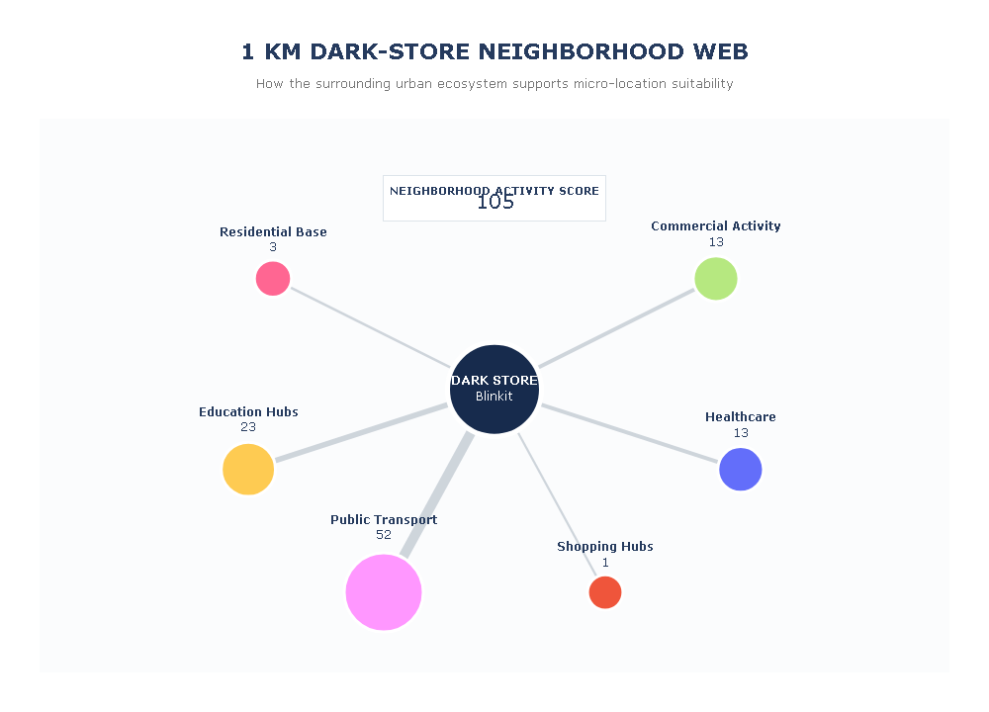
The project therefore examines approximately a 1 km surrounding environment using OpenStreetMap features.
Environmental Signals
Residential → Delivery demand
Public Transport → Accessibility
Education → Recurring activity
Healthcare → Extended activity
Commercial → Economic intensity
Shopping Hubs → Supporting retail activity
Example Location
The selected Blinkit location produced a:
Neighborhood Activity Score = 105
With:
Feature | Score
Public Transport | 52
Education Hubs | 23
Commercial Activity | 13
Healthcare | 13
Residential Base | 3
Shopping Hubs | 1
Important Interpretation
105 is an activity-intensity score, not a percentage or guaranteed location-suitability score.
Core Insight
The goal is not to maximize every surrounding feature.
It is to find the right environmental mix for rapid fulfilment.

12. Notebook 6 — Competitive Market Intelligence
The project next measures competitive pressure.
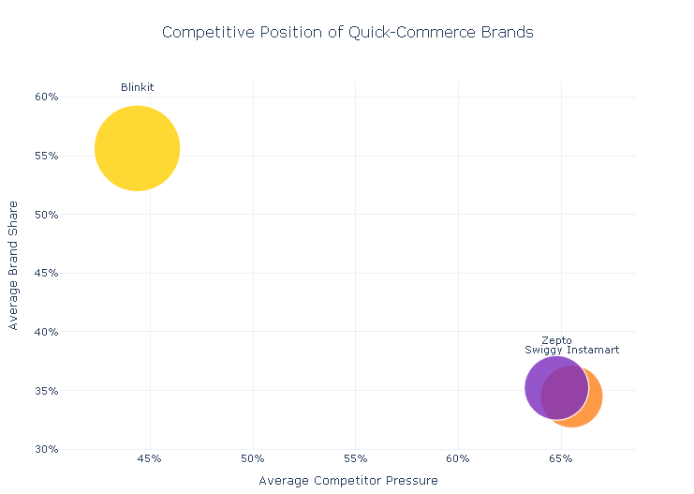
Brand Competitive Position
The model compares:
Competitor Pressure × Brand Share × Network Presence
Blinkit shows the strongest competitive position with relatively high brand share and lower competitor pressure.
Zepto and Swiggy Instamart operate in more contested environments, with competitor pressure around the mid-60% range.
Key Formula
High Brand Share + Low Competitor Pressure = Stronger Local Market Control
But competitive structure changes significantly between locations.
A company that is weaker nationally may still dominate an individual market.
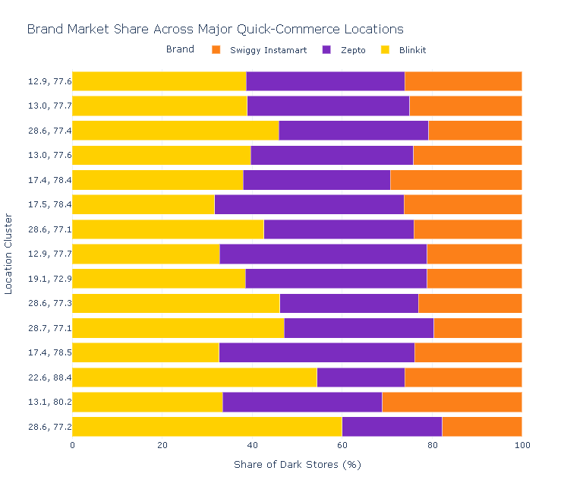
Strategic Interpretation
High Demand + Low Competition → Expansion Opportunity
High Demand + High Brand Diversity → Competitive Battleground
High Density + Balanced Shares → Possible Saturation
High Existing Brand Share → Stronghold Market

13. Notebook 7 — Location Opportunity Engineering
Now the project combines demand and competition.
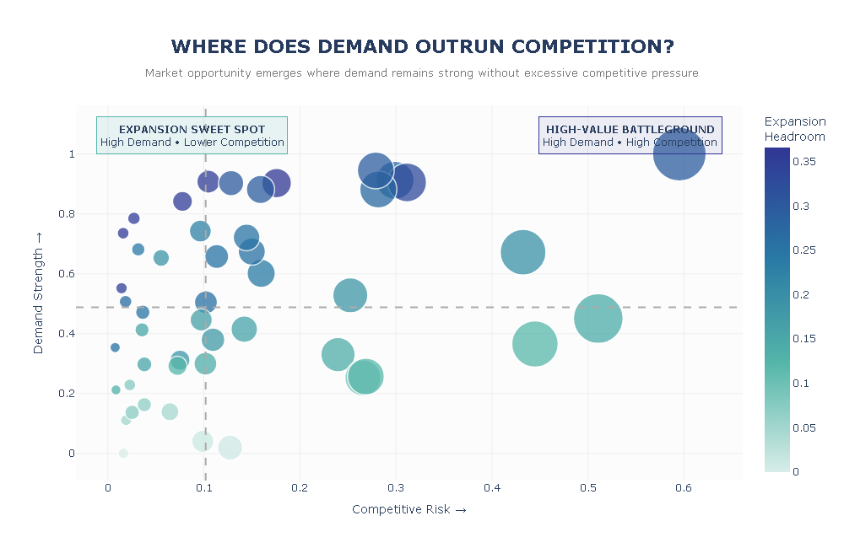
Core Concept
Demand + Competition → Expansion Opportunity
Stores are assigned to the nearest available demand market using geographic distance.
A 50 km reliability threshold produces:
3,232 decision-ready stores
Brand | Reliable Stores
Blinkit | 1,448
Zepto | 1,014
Swiggy Instamart | 770
There are 0 missing demand scores among the resulting decision-ready records.

14. Demand–Competition Opportunity Matrix
Markets are divided into four strategic quadrants.
Demand | Competition | Classification
High | Low | Expansion Sweet Spot
High | High | Battleground
Low | Low | Emerging Market
Low | High | Weak Risk–Reward
Core Insight
The best market isn't necessarily the one with the highest demand. It is the market where demand remains strong relative to competition.

15. Expansion Headroom
Three additional signals are engineered.
Demand Gap
Demand adjusted for market saturation.
Expansion Headroom
Demand adjusted for competitor pressure.
Market Control
Demand combined with existing brand strength.
These metrics move the analysis from:
“Where is demand high?”
to:
“Where does enough untapped demand remain to justify expansion?”

16. Notebook 8 — Location Opportunity Scoring Model
The engineered variables are combined into a single:
Location Opportunity Score / 100
Model Weights
Factor | Weight
Demand Strength | 40%
Competition Opportunity | 20%
Competitor Pressure Opportunity | 15%
Local Brand Strength | 15%
Density Opportunity | 10%
Higher scores indicate stronger potential for expansion.

17. Model Results
Across 3,232 validated locations:
Metric | Score
Average | 57.13
Median | 58.26
Maximum | 100.00
Minimum | 26.45
The scoring model therefore separates locations where demand and competitive conditions support expansion from locations where saturation or competitive pressure reduces attractiveness.

18. Sensitivity Analysis
One weighting system should not automatically determine a major expansion decision.
The model is therefore tested under three strategies:
Balanced
Uses the original multi-factor weighting.
Demand-Focused
Places greater importance on market demand.
Low-Competition
Prioritizes markets with greater competitive whitespace.
Why This Matters
If a market only ranks highly under one particular weighting assumption, the recommendation may be fragile.
A market that remains attractive under multiple strategies provides stronger decision confidence.
Core Principle
Opportunity Score measures attractiveness. Ranking Stability measures confidence.
The source analysis explicitly uses sensitivity testing to reduce dependence on arbitrary model weights.

19. Robust Expansion Markets
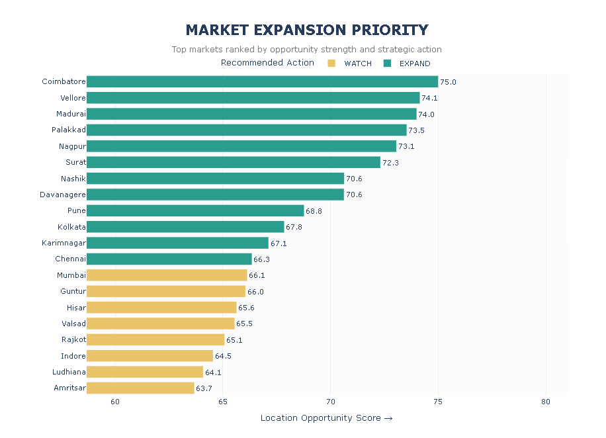
Sensitivity analysis produces several interesting markets.
Coimbatore
Strongest baseline opportunity ranking.
Madurai
Consistently strong across all three strategies.
Vellore
High and relatively stable ranking.
Nagpur & Surat
Improve under demand-focused expansion.
Palakkad
Performs especially well when low competition is prioritized.
Mumbai & Chennai
Remain attractive but become less favourable when competitive risk receives greater weight.
Key Insight
Madurai emerges as one of the most strategically robust markets, while Coimbatore provides the strongest baseline opportunity.

20. Notebook 9 — Market Segmentation & Expansion Strategy
Analytical scores are converted into business actions.
48 Markets Evaluated
Each market receives one of four classifications:
EXPAND
Strong opportunity with manageable competition.
WATCH
Promising but requires further validation.
LOW PRIORITY
Weak current expansion potential.
BATTLEGROUND
Strong opportunity but excessive competitive intensity.

21. Strategic Market Results
Strategy | Markets
🟢 EXPAND | 12
🟡 WATCH | 12
🔴 LOW PRIORITY | 24
⚔️ BATTLEGROUND | 0
Total | 48
Interpretation
25% of markets qualify as expansion priorities.
Another 25% require monitoring.
Half currently have relatively weak expansion potential.
No market simultaneously satisfies the model's high-opportunity and high-competition thresholds required for the Battleground category.

22. Expansion Decision Framework
The project ultimately transforms complex location data into a simple business framework:
EXPAND
Prioritize site-level feasibility studies.
WATCH
Monitor demand, competitors and network development.
LOW PRIORITY
Avoid aggressive expansion under current conditions.
BATTLEGROUND
Enter only with a strong competitive or strategic justification.
This converts:
48 Markets → Scoring → Segmentation → Ranking → Expansion Strategy

23. Notebook 10 — Interactive Location Intelligence Engine
This is one of the strongest portfolio components of the project.
Instead of leaving the analysis as static charts, Notebook 10 converts the model into an interactive decision-support engine.
Objective
Evaluate any searched Indian location for potential quick-commerce expansion.

24. How the Engine Works
User Inputs
The user can:
- Search for an Indian city/town
- Enter exact latitude and longitude
- Select Blinkit, Zepto or Swiggy Instamart
- Choose the competitive search radius
Processing Pipeline
Location Input
↓
Coordinates
↓
Nearest Reference Market
↓
Local Competitor Detection
↓
Site Score
↓
Expansion Recommendation
↓
Interactive Report

25. Interactive Report Output
The engine can display:
- Searched location
- Reference intelligence market
- Distance to reference market
- Demand Strength
- Market Opportunity
- Reference Strategy
- Nearby stores
- Competitor stores
- Same-brand stores
- Competitor ratio
- Competitive whitespace
- Preliminary Site Score / 100
- Expansion recommendation
- Model-match reliability
- Interactive geospatial map
- Brand-level competitive intelligence
An especially important design choice is that the searched location remains separate from the nearest reference market.
So if someone searches Pachora but Nashik is the nearest intelligence market, the report does not incorrectly present Nashik as the searched location.

26. Model Reliability Layer
The interactive system also communicates uncertainty.
Instead of presenting every result with equal confidence, the recommendation is given a reliability level based on the distance between the searched location and the available reference intelligence market.
HIGH
Strong geographic support.
MODERATE
Useful estimate, but local validation is recommended.
LOW
Reference market is relatively distant and the result should be interpreted cautiously.
This is a good feature because the system communicates model limitations alongside recommendations rather than presenting the score as absolute truth.

27. Major Project Findings
1. Blinkit leads national network scale
Blinkit accounts for 47.9% of the observed 4,081-store network.
2. Competition is geographically concentrated
All three brands cluster around selected markets instead of spreading uniformly.
3. National scale does not guarantee local dominance
Zepto or Instamart can have strong positions within specific local markets despite smaller national networks.
4. Population alone is insufficient
Demand quality requires additional demographic and workforce information.
5. Bangalore leads retail demand
Its RDI of 0.901 exceeds Pune and Mumbai Suburban.
6. High demand does not guarantee expansion opportunity
Competitive saturation can significantly reduce market attractiveness.
7. 79% of stores receive reliable demand assignments
The 50 km threshold produces 3,232 decision-ready locations.
8. Only 25% of evaluated markets qualify for EXPAND
The model identifies 12 expansion-priority markets from 48 evaluated markets.
9. Ranking stability matters
Madurai performs consistently across alternative strategic weighting systems.
10. Expansion decisions can be operationalized
The interactive engine allows the analytical framework to be applied to user-selected Indian locations.

28. Business Recommendations
Prioritize Robust Markets
Use Opportunity Score + Ranking Stability, rather than simply selecting the market with the highest raw demand.
Move from City-Level to Micro-Location Analysis
After identifying an EXPAND market, conduct neighborhood-level feasibility analysis before committing capital.
Use Competitive Whitespace Strategically
High-demand markets with lower competitor pressure should receive greater expansion priority.
Defend Existing Strongholds
Markets with high local brand share may be appropriate for network reinforcement rather than purely new-market expansion.
Continuously Recalculate Scores
Quick-commerce markets change rapidly as competitors open and close dark stores.
The scoring framework should therefore be periodically updated with fresh store and demand data.
Treat the Engine as Decision Support
The model should shortlist and compare candidate locations rather than replace final operational feasibility studies.

29. Project Limitations
A strong documentation should also state what the model doesn't know.
The current system does not fully incorporate variables such as:
- Actual order volumes
- Delivery times
- Property rent
- Dark-store operating cost
- Road congestion
- Rider availability
- Customer-level transaction data
- Competitor revenue
- Real-time store openings/closures
- SKU-level demand
- Actual profitability
Therefore, the Location Opportunity Score represents strategic expansion potential, not guaranteed profitability.

30. Future Scope
The system could be extended with:
Real-Time Competitor Monitoring
Track new dark-store openings and closures.
Property Economics
Add rent and operating-cost information.
Delivery-Time Modeling
Incorporate road networks and traffic.
Customer Demand Forecasting
Predict orders at candidate locations.
Machine Learning
Train models using historical successful and unsuccessful dark-store locations.
Catchment Analysis
Estimate realistic 10–15 minute delivery zones.
Automated Market Reports
Generate downloadable PDF reports for searched locations.
Multi-Location Comparison
Allow decision-makers to compare several candidate sites simultaneously.

31. Final Conclusion
This project develops an end-to-end geospatial decision-support system for quick-commerce expansion.
It begins with 4,081 raw dark-store locations and progressively adds:
Spatial Validation → Geographic Structure → Retail Demand → Micro-Location Environment → Competition → Opportunity Engineering → Scoring → Sensitivity Analysis → Market Strategy → Interactive Decision Support
The analysis demonstrates that expansion decisions should not be based solely on population, store count or market demand.
Instead:
The strongest expansion opportunity occurs where demand, competitive whitespace, brand position and local conditions align.
The final result is therefore more than an exploratory analysis.
It is a location-intelligence framework capable of converting geospatial data into expansion decisions.

